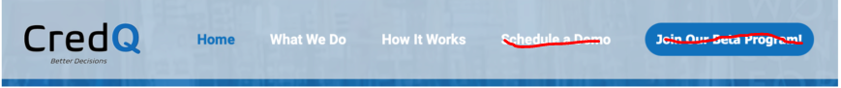

Replace “Schedule a Demo” with “Products” & Replace “Join Our Beta Program” with **“Partner Login”**

When the user clicks on **“Products”**,the below page should show up.

**Schedule a Demo**

**Essentials**

performs risk assessment for unsecured and secured income generating loans

CredQ Score

KYC Authentication

Social Index

Individual Index

Mobile Data Insights

Economic Potential Insights

Government Reports Trends

+ API Integration

+ Monthly Standard Report

+ 24X7 Support- Priority

**Schedule a Demo**

**Premium**

performs risk assessment for all types of loans i.e. education, home, agricultural, two-wheeler, personal and small business loans

CredQ Score

KYC Authentication

Social Index

Individual Index

Agronomic Index

Mobile Data Insights

Geospatial Imagery Index

Economic Potential Insights

Government Reports Trends

+ API Integration

+ Customize Loan Tracker

+ 24X7 Support- Priority

**Put a tick sign in front of features (from Social Index onwards) we are offering in an above table. --**  

**Partner Login Page**



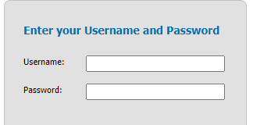

Login



Replace Username with ‘User ID’

* We will provide the login details to our partnered financial institutions. Once the user clicks to Login, it will direct them to - Platform Wireframes doc.

If you have an idea to make it better, I’m open to it as well.